**What Social Media Does Boston University Use the Most?**

Carlos Lopez

KHC PY102 A1

Dr. Klein

18 December 2019

**Abstract:**

A social media survey was done to test what social media is used the most among the people that most frequently interact with Boston University which included BU’s students, workers, and staff. However, due to the low turnout of “non-students” the results can only be generalized to BU students. This study was done simply out of curiosity, but this data proves useful to advertisers who might be deciding on where to advertise their next product or just the average BU student who might be trying to spread word of his new study or party in the most efficient manner possible. The results pointed to Instagram being the most used social media in BU with Snapchat being the second. In addition, these results seem to remain consistent despite the college that is looked at. In other words, when looked at individually, colleges like Questrom and CAS seem to display the same results of their attendees preferring Instagram the most and Snapchat almost as much.

**Introduction:**

Social media is a ubiquitous aspect of many peoples’ lives due to its multi-faceted capabilities. Not only is it used for entertainment, but it also is used by many to keep themselves informed as to what is happening in the lives of their friends and family as well as what is happening in the world at large. Therefore, with a tool this versatile there will of course be several versions from different creators trying to give their own personal spin to it and people who prefer one version over the other. Hence, I wanted to see what the main preference for social media is around the Boston University campus since BU harbors many individuals from many different ethnicities, nationalities, and opinions.

**Procedures:**

Firstly, a survey was made in Google forms which you can see for yourself here:

<https://forms.gle/Mf5vWwyBcrHxYuiL8>

Besides the key question of “What social media platform do you use the most?”, the survey had several identifying questions regarding gender, age and place of upbringing. However, no names or emails were recorded to keep peoples’ identities and information confidential. In addition, the survey branched out halfway through into two different versions depending on whether the one taking the survey was a student or a “non-student” which refers to any worker, staff, or visitor at BU. This was done to allow anyone present in BU to take the survey regardless of their affiliation to the university.

Furthermore, some measures were taken to eliminate any confounding variables within the survey. For example, by the exception of a few questions such as “State your age” and “Where did you grow up?” the questions within the survey are all multiple choice to provide the taker enough options to avoid responses such as “I don’t know” or “I’m not sure.” However, these answer choices were also set to shuffle into a random order whenever someone tried to take the survey. This was done so that the order in which the answers were presented did not affect the results of the survey since often times people try to finish surveys as fast as possible and just pick the first answer that they see. By this same logic, the survey was also made to be as short as possible so that everyone who started the survey would not get tired of it or put it aside before finishing it.

The survey was open for a week during which time anyone related to BU could take it as long as they had seen either the QR code or the link directing to it. In order to spread awareness of this survey, several posters (pictured below) were printed and placed in several locations throughout BU’s campus such as the Warren, West, and Bay State dining halls. However, several other posters were also printed to be in non-stationary locations such as taped to the back of the backpacks of three of my peers each of which lives in a different dorm (Warren, West, and Kilachand). In addition, I also got quite a few responses by asking whoever came across me to take the survey. The survey takers were also encouraged to spread word of this survey to their fellow peers but were instructed to not post pictures or spread word of the poster in any social media platform since this might affect the final results.

In an attempt to get more participants for the survey, the poster was made to be as eye-catching as possible. Therefore, bold red ink and the Impact font were used for the title of “HEY YOU!” as well as the image of a hand pointing at the individual reading the poster. In addition, the information in the poster starts with an appeal to a feeling that everyone can relate to, the hurry and stress of last minute work. This was done so that afterwards, readers are more inclined to actually go through with the survey since the grand majority of the population can emotionally relate to this feeling due to having been in a similar situation themselves. Afterwards, the poster provides a QR code that anyone with a phone can scan through their camera app, and an alternative link that also takes them to the same survey in the case that they can’t scan the QR code for whatever reason. Finally, proper thanks are given since the survey takers ARE doing me a favor by taking time out of their busy lives to help me out.

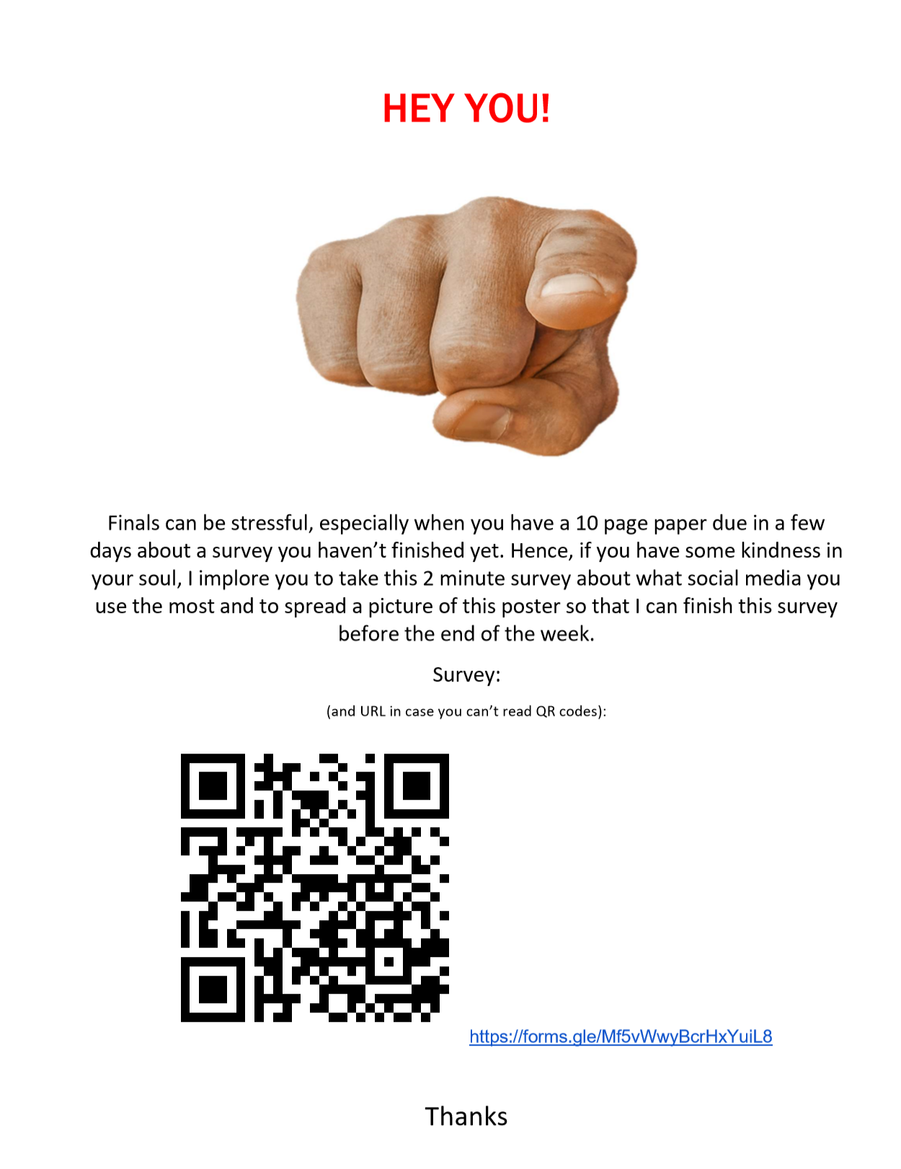

**Analysis:**

Out of the 108 total survey takers, Instagram was the most used social media platform with a grand total of 40 (37%) survey takers choosing this option. Snapchat came in on a close second place with a total of 30 (27.8%) votes, and Reddit came in considerably far behind on a third place with 13 (12%) votes.

In addition, here’s some information regarding the types of people that took my survey.

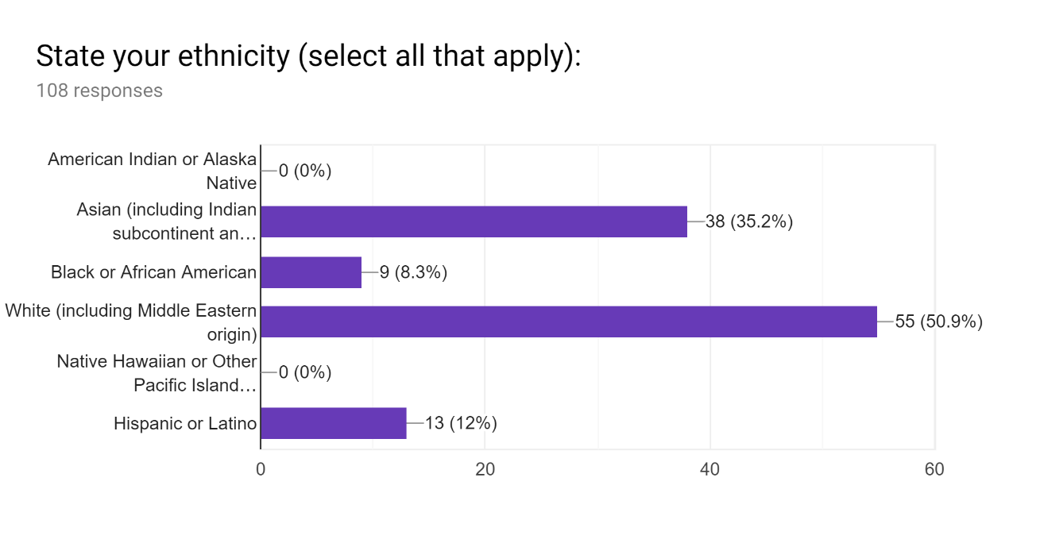

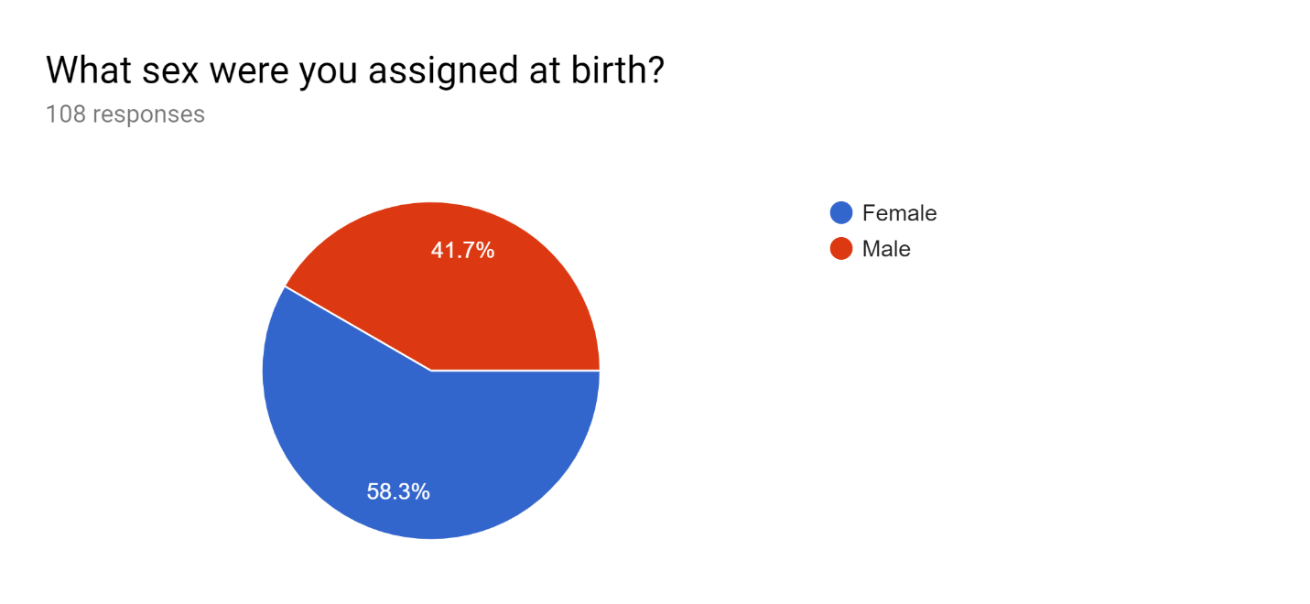

Surprisigly enough, although I was under the impression that the small sample size for this survey would affect the voter distributions, it seems as though most of the voter distributions, such as the distribution of sexes among my survey takers, stayed roughly within what the actual distribution of survey takers was for the whole population. For example, there are several articles about BU and by BU that state that the female to male ratio is roughly around 60% to 40% (see: <https://www.usnews.com/best-colleges/boston-university-2130>) and this is reflected in the graph above.

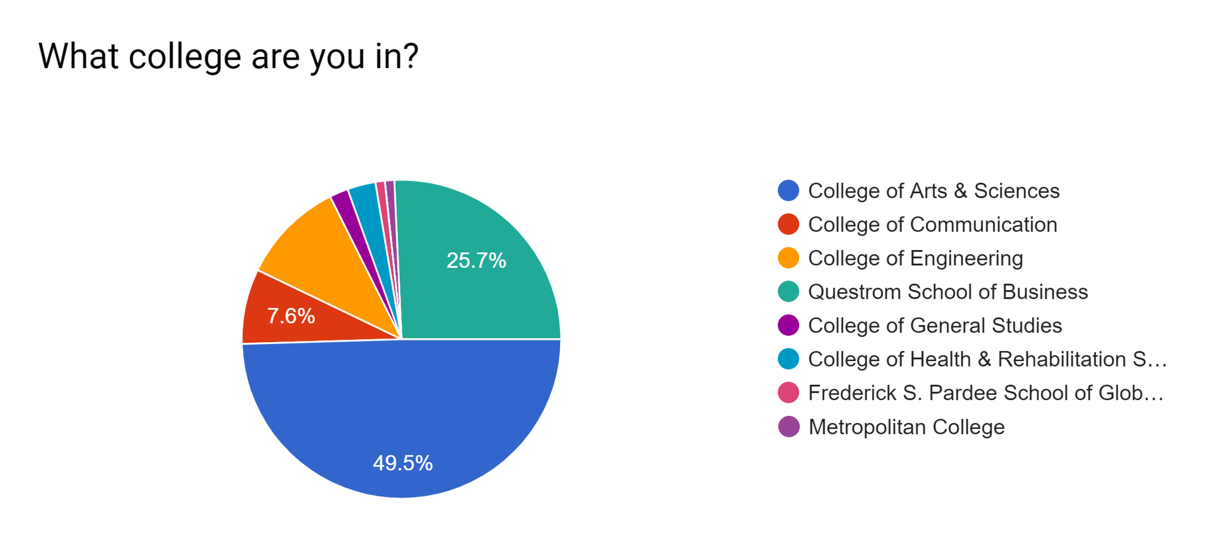

The same could be said for the last graph in the previous page which talks about the different colleges from where survey takers came from. Despite not having survey takers from all the colleges answer the survey, the overall proportion of college sizes stays relatively true to that of the overall population of all the colleges of BU with CAS being the biggest by far.

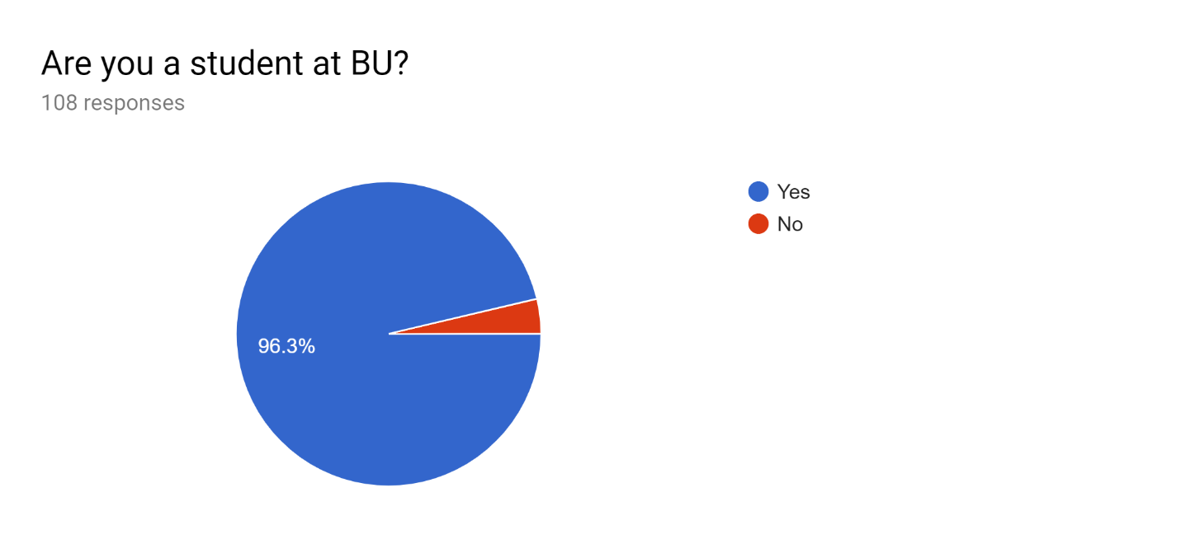

It was this last graph that made me reconsider who this survey could be generalized to. Originally, this study was supposed to account for the entirety of BU’s population, including workers and staff members. However, as you can see most of the responses actually came from students, and although this distribution of students to staff/workers still falls in line with the 10 to 1 student to faculty/staff ratio that is reported of BU (again, see: <https://www.usnews.com/best-colleges/boston-university-2130> or <https://www.bu.edu/admissions/why-bu/facts-and-rankings/> or for more detailed information <https://www.bu.edu/president/boston-university-facts-stats/>), I simply do not think that enough responses were gathered from the non-student population to generalize for all of the people of BU.

**A small concern…:**

At first, I was intrigued by the fact that WeChat came out so low in the ranking of preferred social media. I’d heard that it was a popular platform in China due to all social media being banned there by the exception of a couple of platforms, out of which WeChat was the most popular. I also had several survey takers who had said they grew up in China. This made me concerned that the survey had produced erroneous results. Therefore, I decided to interview several Chinese international students to get their take on why WeChat was so underrepresented in my survey, and to my surprise, they weren’t concerned with the results at all. The general consencus that I got regarding the low percentage of WeChat users was that WeChat is only popular within China. In other words, international students don’t use WeChat as much once they move out of China since their fellow peers use other types of social media and they need to adapt to keep in touch with their new friends.

**Possible Reasons for Errors:**

When considering the accuracy of these results, I believe one should mainly look at the way the survey takers were gathered since that seems to be the place where the most errors could have occurred. For example, despite me putting up posters in the main four dining halls of BU, I did not put up a poster in the Fenway Dining Hall or the Hillel Dining Hall which may exclude any possible BU student who might only eat in either of those two places. In addition, the 3 friends that I used to advertise my survey do not equally represent all of the BU colleges. One of them goes to Questrom, one goes to CAS, and another goes to the College of Engineering, and this might account for the majority of survey takers coming from those places. In addition, I did not take into account any BU student that may not have been in the school at the time the survey was taken. Take for example the students that are currently doing studies abroad or the students who simply don’t take a fall semester at BU.

**Conclusion:**

Just like in any other type of statistical study, a bigger sample size and more data would have been great. Nevertheless, I believe that some pretty clear answers were gotten from this survey, mainly that Instagram has a very high likelihood of being the most used social media platform in BU and that Snapchat also has a very high likelihood of being the second. I showed these results to several of my peers and most of them agreed that the results made sense with the data that I collected. To quote one of the people I showed these results to: “I’m not surprised. Instagram is a lot more popular for younger people while Facebook is used more by Boomers.”

If I had the chance to redo this survey (or if anybody else would like to redo it), I think I’d keep most of the things the same. However, I’d definitely go out of my way to get more older people to answer my survey since they seemed to be the ones with the least responses here though I’ll admit I would struggle to find a lot of older people since most people in BU are really young. I also thought I had enough time to complete this study, but in retrospective I was pretty rushed through it all. Therefore, if I had the opportunity, I’d also start this study a lot earlier than I did this time and if possible, I would allocate times to visit every college in BU so as to not ignore any one of them. I would probably also ask a few of my peers for help, not only because this task would take up a lot of my time but because that would also reduce any biases that I may subconsciously have against surveying certain people.